
SOP Title: | eCommerce Refusals Processing
Document Storage Location: | STACS/Management/SOPs – Logistics and Warehousing | Document #: | SEASOP433v100
SOP Originator: | Avika Raja | Last Edited by: | Erwin Dela Pena
Effective Date: | 08/06/2021 | Last Edited Date: | 12/18/2023
Other: | Visibility and NERP access required.

- Purpose
  - To outline the customer refusals process, which must be processed within 48 hours once arrived (24 hours for receiving, 24 hours for Put Away).
- Scope
  - Coppell eCommerce (eComm): All refusals sold through Samsung.com.
- Responsibilities
  - The 3PL eComm team (3PL) shall be responsible for the systemic 3PL WMS (Warehouse Management System) processes and physical activities within eComm operations.
  - The SEA Logistics Planning & Services (LPS) eComm team shall provide oversight for 3PL operations and validate performance.
  - The 3PL eComm and SEA LPS eComm teams shall collaborate on troubleshooting procedures for Exceptions processing when required.
- Instructions
  - Customer Refuses Product
    - Carrier attempts to deliver the product to the customer.
    - Customer refuses the product.
      - The customer does not respond to delivery attempts or actively rejects the product. Product is never opened.
  - Carrier returns the refused product to the Coppell Warehouse using a new tracking number.
  - Arrival
    - The product arrives at the Coppell Warehouse door assigned for carrier delivery.
    - The 3PL Returns Team associate goes to assigned dock door and
      - Performs a dock scan of the tracking number
      - Separates the shipment based on type of return material:
        - Returns (See SEASOP434v100)
        - Refusals
        - Non-eComm (See SEASOP436v100)
    - The associate counts the delivered packages.
      - Associate verbally provides SEA Security with number of boxes counted.
    - The associate confirms dock scan information with Carrier.
      - If dock scan information is incorrect, reconcile number of missing boxes with Carrier.
      - If dock scan information is correct, proceed to next step.
    - The associate brings the Refusals material to an available eComm Returns Area space.
    - The associate performs an arrival scan in 3PL WMS.
    - The associate moves the material to an available space in 3PL Workstation Area.
  - 3PL’s Processing in 3PL’s WMS
    - Refusal shall be received within 24 hours of POD (proof of delivery).
      - If 3PL does not receive refusal within 24 hours, SLA (Service Level Agreement) is not met.
    - Product arrives at workstation for processing by 3PL eComm Team associate.
      - Open package.
      - Type PO ID on packing list into 3PL WMS.
        - Entering the PO ID generates an RMA code for the product.
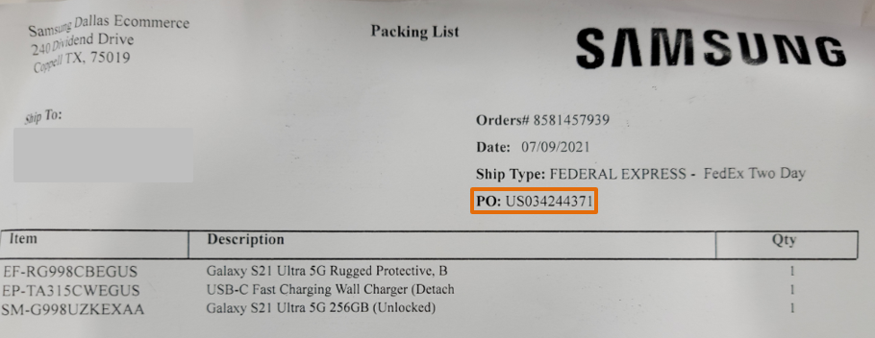
        - Packages that are refusals do not arrive at the warehouse with RMA codes because the customer did not log onto Samsung.com to initiate return process.
PO ID can be found on packing list inside of package.

      - Confirm product SKU and quantity match in 3PL WMS.
        - If SKU and quantity match, proceed to Assessment step. (4.D.3)
        - If SKU does not match, check Workbench for customer order information.
          - Move package to exceptions cart.
          - Follow Exception procedure.
        - If quantity does not match, check Workbench for customer order information.
          - If all items are missing
            - Move package to exceptions cart.
            - LPS team will research and inform the claims team to file a claim. Item will be logged into a refusal report.
            - The claims team will notify LPS that a claim has been filed and they will then notify the 3PL to move forward to process the refusal as an Empty Box.
          - If some items are missing
            - Move package to the exceptions cart.
            - LPS team will research and inform the claims team to file a claim. Item will be logged into a refusal report.
            - The claims team will notify LPS that a claim has been filed and they will then notify the 3PL to move forward to process the refusal according to what has been received.

    - Associate assesses product box.
      - Product Information Validation
        - Products scanned for serial number (S/N) include
          - Accessories (watch bands, phone cases)
          - Chargers (including wireless)
          - Galaxy Buds
        - Products scanned for IMEI include
          - Watches
          - Phones
          - PCs
      - If product was not shipped back inside of original product box
        - Check S/N or IMEI on product itself to confirm match in 3PL WMS.
          - If product S/N or IMEI match
            - Repack product in new product box.
            - Proceed to Put Away Preparation step. (4.D.4)
          - If product S/N or IMEI do not match
            - Repack product in new product box.
            - Move product to exceptions cart.
            - Follow Exception procedure.
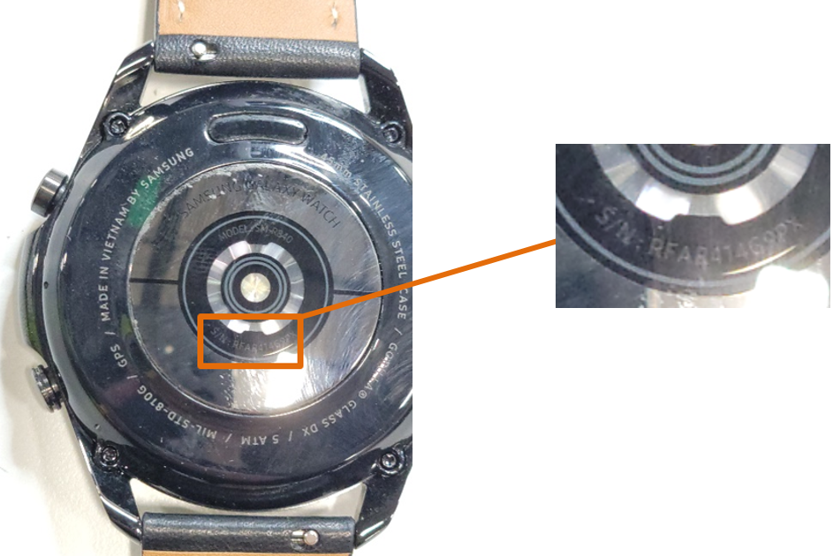
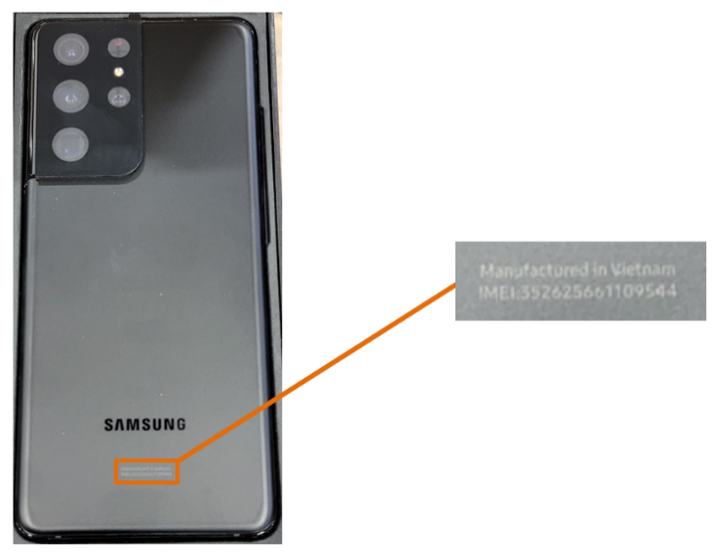
Enter S/N found on product in 3PL WMS.
Enter IMEI found on product in 3PL WMS.

      - If original seals on product box are not broken
        - Scan S/N or IMEI on product box to confirm match in 3PL WMS.
          - If S/N or IMEI match, proceed to Put Away Preparation step. (4.D.4)
          - If S/N or IMEI do not match
            - Put product on exceptions cart.
            - Follow Exception procedure.
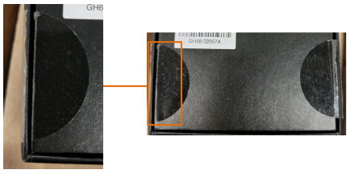
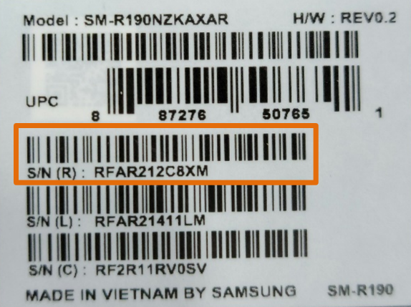
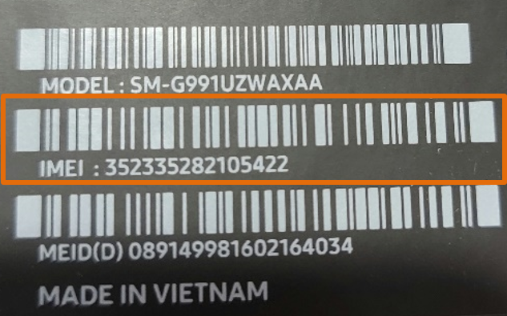
Scan S/N on product box in 3PL WMS.
Scan IMEI on product box in 3PL WMS.

      - If original seals on product box are broken
        - Check contents for missing items.
          - If RMA shows all items are accounted for
            - Check S/N or IMEI on product itself to confirm match in 3PL WMS.
              - If product S/N or IMEI match
                - Reseal product box.
                - Proceed to Put Away Preparation step. (4.D.4)
              - If product S/N or IMEI do not match
                - Reseal product box.
                - Put product on exceptions cart.
                - Follow Exception procedure.
          - If RMA shows items not accounted for and
            - All items are missing
              - Move package to exceptions cart.
              - LPS to investigate and provide disposition. They will tell the claims team to file a claim
              - Once a claim is filed, LPS will tell 3PL to process as unsent.
            - Some items are missing
              - Move package to the exceptions cart.
              - LPS to investigate and provide disposition. They will tell
the claims team to file a claim.
              - Once a claim is filed, LPS will tell 3PL to process as unsent.

    - Put Away Preparation (performed by 3PL Associate)
      - If original seals on product box are not broken, product belongs in A-stock.
Broken seals on product box.
        - Apply LIP (license plate) to new package box and scan.
        - Scan Acceptable (ACC) location code and Available (AV) reason code on workstation desk.
        - Indicates product is available for picking in interim virtual bin in A-stock.
        - Apply ‘Partial’ sticker to package box.
          - Cues picker to pick Partial box before vendor-sealed full box.
        - Write location listed in 3PL WMS on Partial sticker.

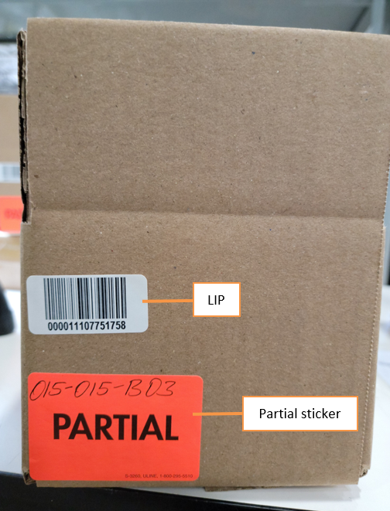
License plate (LIP) and Partial sticker are added to new package box for A-stock Put Away.
      - If original seals on product box were broken or product box was missing, the re-sealed product belongs in C-stock.
        - Scan item number and IMEI or S/N.
        - Apply LIP to product box and scan.
        - Scan Damaged DAM) location code and Return (RT) reason code on workstation desk.
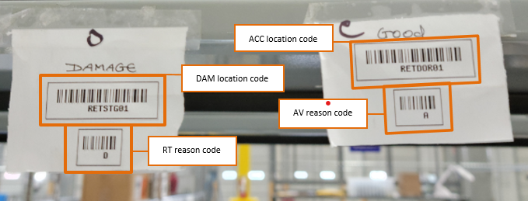
          - Indicates product is available in interim virtual bin in B-stock.
Location and reason codes for A-stock and B-stock are located on 3PL associate’s workstation desk.

    - Confirm transactions in 3PL WMS.
    - AS an additional check, associate checks refusal information listed in 3PL WMS to ensure SKU and quantity match description.
      - If information does not match, process as Exception.
    - Complete the Return in 3PL WMS.
      - If product was DAM/RT, proceed to Put Away step 4.
      - If product was ACC/AV
        - Scan LIP again.
        - Change inventory status to “available” for picking.
        - Give ‘Reason for Change’ as “Put Away”.
      - Refusal is closed out in 3PL WMS.
      - Proceed to next step.
  - Put Away (done by 3PL associate on warehouse floor at EOD)
    - Associate enters Put Away functions in 3PL system.
    - Associate scans LIP.
      - If LIP is for DAM product, LIP is on product box.
      - If LIP is for ACC product, LIP is on package box.
    - If product is ACC/AV, go to A-stock pick front on warehouse floor.
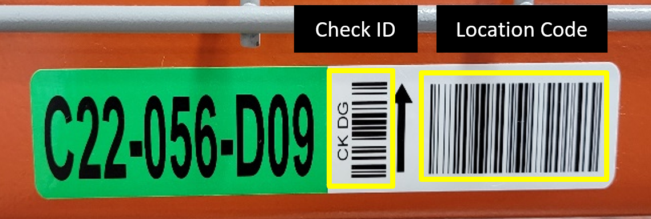
    - If product is DAM/RT, go to B-stock bin location on warehouse floor.
Scan Check ID and location code on warehouse shelf.

    - Scan location code on stock shelf to confirm match in 3PL WMS.
      - If location in 3PL system matches LIP, scan Check ID on shelf.
      - If 3PL system location does not match LIP, change location in 3PL system by scanning location code and Check ID on shelf.
    - Associate places product in assigned shelf location.
      - If product is DAM/RT, place in white bin.
      - If product is ACC/AV, consolidate in existing boxes.
      - If bin or box is full, use 3PL system to find open bin and enter reason code ‘NB’ (Next Bin) in 3PL system.
        - Change location in 3PL system by scanning location code and Check ID on shelf.
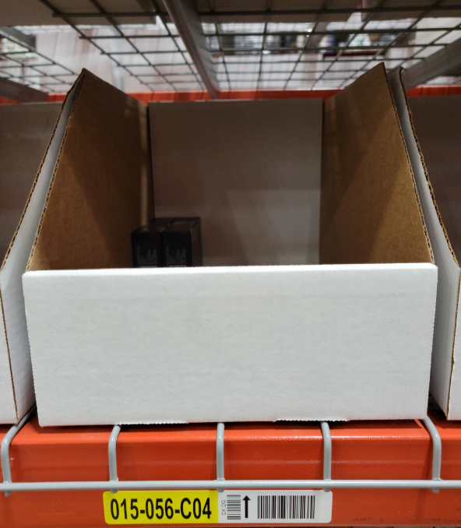
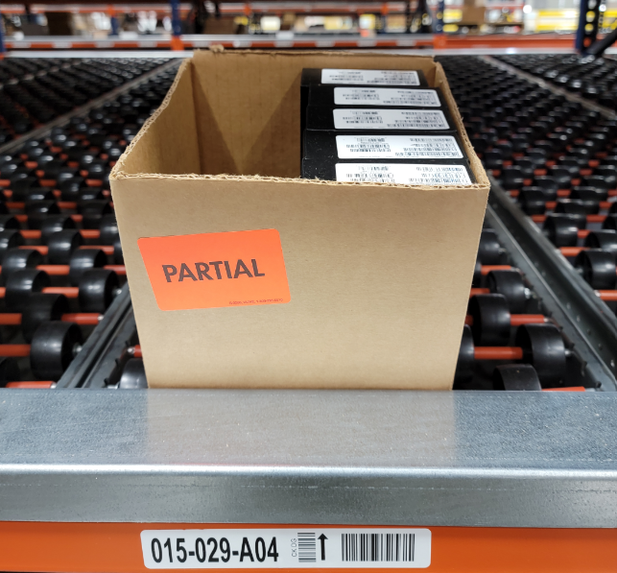
B-stock product is consolidated in white bins on warehouse shelf location.
A-stock product is consolidated in Partial boxes on warehouse shelf location.

